Guidelines to be followed for the Geoprogress Journal and other documents written in English

Please, make sure the document adopts the following options related to page margins which can be selected in the menu named “Page Layout”.

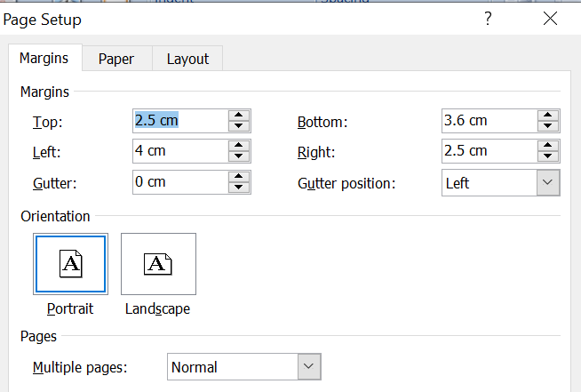

The font employed in all Geoprogress publications is “Times New Roman”. Please, make sure the size is 12, the main content of the text (excluding titles) is “Justified” and black colour is selected.

For the text included in the paragraphs (thus excluding titles, abstract, bibliography and footnotes) it must be selected a line spacing equal to 1.0 (through this icon ). The language selected across the document should be (selection is possible on the bottom left of the page). For publications in Italian please select .

In the following pages it is reported a set of additional indications necessary for the formatting of different sections of the document. Please, feel free to use this document whose format is already consistent with Geoprogress publications format guidelines as a base to copy and paste your text.

The next page presents an already formatted first page of the paper, which the correct formatting and positioning of title, authors name and surname, abstract, paragraphs titles.

Please, remember to save the file with the “.docx” extension.

For further information, please contact Edoardo Ardizzone at edo.ardizzone@gmail.com

TITLE OF THE DOCUMENT

Author1 name surname∗, Author2 name surname, Auhor3 (..)

Abstract
Title and authors must be aligned selecting “center” (please do not modify the line spacing, “Before: 0 pt”, “After: 0 pt”). “UPPERCASE” should be selected for the title. Two empty lines separate the title from authors’ name and surname list. Three empty lines separate the list of authors and the text “Abstract” which must be in italic and must present a 6 pt spacing, below, (line spacing can be selected in the “Paragraph” window). The content of the abstract should be aligned selecting “Justify” and the following options should be selected for spacing:
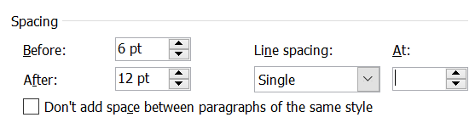
At the end of the abstract, a further empty must be present, just before the title of the first chapter. The empty line must not have any spacing (“Before: 0 pt”, “After: 0 pt”).

1. Heading 1
The title of the main chapters must be aligned on the left (), “bold” must be selected and it must be numbered using the format 1. , 2. , 3. , etc. Before the titles of main chapters an empty line must be entered. The spacing of main titles should be:

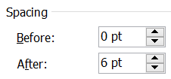

The main text of the paper should instead follow the rules explained at the beginning of this document.

Subchapters’ titles should be formatted as follows:

1.1 Heading 2

Before each subchapter it must be entered an empty line. The font of these sub-chapters titles (1.1, 1.2, 1.3, etc,) must be italic and the spacing must be:

Further sub-chapters should be formatted as follows:

1.1.1 Heading 3

The spacing for these sub-chapters titles (1.1.1, 1.1.2, 1.1.3, etc,) must be:

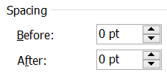

Bullet lists should be formatted as follows:

- Item 1
- Item 2
- Item 3
While those for numbered lists:

- Item 1
- Item 2
- Item 3
The following spacing must be adopted for bullet lists:

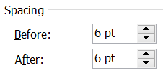

Tables should be formatted as follows:

Title 1 | Title 1 | Title 3
Table 1: Title of the table.
Source: Own elaboration.
The spacing referred to the table is:

While the one of the table title (in italic) must be:

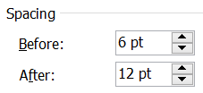

The same formatting is applied to images and graphs.

Please refer to the footnote of this page for footnotes format.

The title of the section related to references must not be numbered and must adopt the same format as the main headings.

References
The references must adopt the following format:
Adamo F. (2017), Patrimonio culturale e sviluppo locale, Annali del Turismo, Vol. VI, pp. 11-18.
Grove A.T. (1980), Geomorphic evolution of the Sahara and the Nile, in M.A.J. Williams & H. Faure (eds.), The Sahara and the Nile, Rotterdam: Balkema.
Kaika M. (2003), The Water Framework Directive: a new directive for a changing social, political and economic european framework, European Planning Studies, 11(3), pp. 171-202.
The spacing of references must be:

∗ The author’s mailing details should be inserted here. An example is: “Author, Department of (..), University of (..), E-mail address: author@geoprogress.it.” If there are two or more authors, please specify the different contributions to the paper.
The font of the footnote has to be Times New Roman, size 10 aligned on the left.

